1. Period and Frequency of a Circular Motion

a) Set up a constant velocity car to do circular motion:
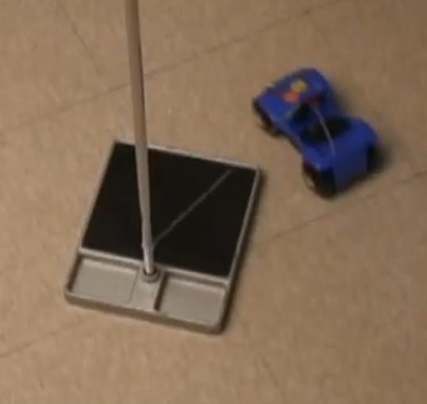
b) Time 2 and 3 complete cycles, find the period and frequency of the car

Time taken for 1 cycle | Time for 2 cycles | Time for 3 cycles | Period (s) | Frequency(Hz)

2. Linear and Angular Velocity, Centripetal Acceleration
Find the Linear velocity and angular velocity of the circular motion, write the units in the brackets:

a) Measure the radius of Curvature _____________, Convert it to meters: R= ___________ (meters)

b) The linear velocity of the car: $v=\frac{2πR}{T}=$________________ unit: ( )
c) The angular velocity of the car: $ω=\frac{Δθ}{t}=$______________ unit: ( )
d) The angular velocity of the car: $ω=\frac{v}{R}=$______________ unit: ( )
e) The centripetal acceleration of the car: $a_{c}=\frac{v^{2}}{R}$_______________ unit: ( )
fi) The centripetal acceleration of the car: $a_{c}=ω^{2}R$_______________ unit: ( )

Did you get the same or different results from above c) and d) ?

1. Period and Frequency of a Circular Motion
a) Set up a Conical Pendulum to do uniform circular motion:
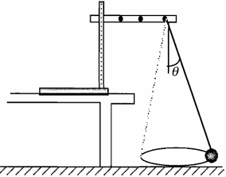

b) Time 2 and 3 complete cycles, find the period and frequency of the car

Time taken for 1 cycle | Time for 2 cycles | Time for 3 cycles | Period (s) | Frequency(Hz)

2. Linear and Angular Velocity, Centripetal Acceleration

Find the Linear velocity and angular velocity of the circular motion, write the units in the brackets:

a) Measure the radius of Curvature _____________,

Convert it to meters: R= ___________ (meters)

b) The linear velocity of the car: $v=\frac{2πR}{T}=$________________ unit: ( )

c) The angular velocity of the car: $ω=\frac{Δθ}{t}=$______________ unit: ( )
d) The angular velocity of the car: $ω=\frac{v}{R}=$______________ unit: ( )

e) The centripetal acceleration of the car: $a_{c}=\frac{v^{2}}{R}$_______________ unit: ( )
fi) The centripetal acceleration of the car: $a_{c}=ω^{2}R$_______________ unit: ( )

Did you get the same or different results from above c) and d) ?

